Stat 130A Two results on the Poisson mgf
F. J. Samaniego

I derived the mgf’s for the Binomial and Geometric models in class, and mentioned the continuity property of mgf’s (which provides an alternative approach to establishing the “law of rare events”), but I didn’t give you the details on the Poisson mgf that you’d need to investigate the latter issue. Here’s the info on both.

Example. Suppose X ~ P(λ). Then (using your favorite trick…, ….ok, using my favorite trick),
m_{X}(t) = 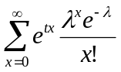 = 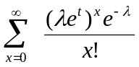 = 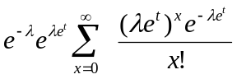 = 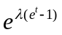,
the last step justified by the fact that the summand has been “massaged” into a perfect set of Poisson probabilities, i.e., the probabilities, from 0 to ∞, of the distribution P(λe^{t}). ■

Theorem (The Law of Rare Events): Let X_{n} ~ B(n, p). If n → ∞ and p → 0 while the product np → λ for some number λ > 0, then X_{n} 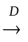 X, where X ~ P(λ).

Proof: This follows from the fact that 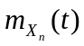 → 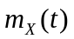, which we verify below:
= 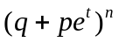 which, by our assumptions, has the same limit as 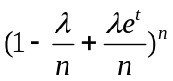 = 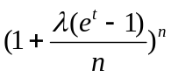 → (recalling the fact that 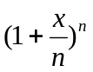 → 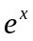). ■

Ok, I did say in class that the continuity property of mgf’s leads to a one-line proof of the law of rare events. I wasn’t lying. If we take the symbol to mean “asymptotically equal” (or equal in the limit), then we may write the proof above as

= = → = . Tada.

